CS701-High Performance Computing Lab
LAB Assignment 02

ANAND M K
RollNo: CS242CS008

Objective: Design of Scalable Mesh-Based NoC Topology

8 * 8 MESH (Wired)

Configuration File :

# Simple default config of a 4x4 mesh
# Each parameter is overwritten when corresponding command line value is set
#
# NOC & WIRED CONFIGURATION
#
# Topologies:
# MESH
# BUTTERFLY
# BASELINE
# OMEGA
#
# BUTTERFLY, BASELINE, and OMEGA are Delta Network topologies
#
topology: MESH
# X and Y mesh sizes
mesh_dim_x: 8
mesh_dim_y: 8
# number of flits for each router buffer
buffer_depth: 32
# size of flits, in bits
flit_size: 32
# lenght in mm of router to hub connection
r2h_link_length: 2.0
# lenght in mm of router to router connection
r2r_link_length: 1.0
n_virtual_channels: 1

# Routing algorithms:
# XY
# WEST_FIRST
# DELTA
# NORTH_LAST
# NEGATIVE_FIRST
# ODD_EVEN
# DYAD
# TABLE_BASED
# Each of the above labels should match a corresponding
# implementation in the routingAlgorithms source code directory
routing_algorithm: ODD_EVEN
routing_table_filename: ""

# Routing specific parameters
# dyad_threshold: double
dyad_threshold: 0.6

# Selection Strategies:
# RANDOM
# BUFFER_LEVEL
# NOP
# Each of the above labels should match a corresponding
# implementation in the selectionStrategies source code directory
selection_strategy: RANDOM

#
# WIRELESS CONFIGURATION
#
Hubs:
defaults:
# channels from which Hub can receive/transmit
rx_radio_channels: [0]
tx_radio_channels: [0]
# list of node tiles attached to the hub
attached_nodes: []
# size of buffers connecting the hub to tiles
to_tile_buffer_size: 4
from_tile_buffer_size: 4
# size of antenna tx/rx
rx_buffer_size: 4
tx_buffer_size: 4

# for each hub, the same parameters specified above can be customized
# If not specified, the above default values will be used
# What is usually needed to be customized specifically for each hub is
# the set of nodes that are connected to it. In this simple topology
# we have 4 hubs (0-3) connected to the four nodes of the 2x2
# sub-meshes

0:
attached_nodes: [0,1,4,5]

1:
attached_nodes: [2,3,6,7]

2:
attached_nodes: [8,9,12,13]

3:
attached_nodes: [10,11,14,15]

# Transmission channels configuration
# each channel modelizes the transmission over a given frequency that
# can be used by a set of communicating hubs
RadioChannels:
defaults:
# data rate in Gb/s affect the number of cycles required for a
# flit transmission
data_rate: 16
# bit error rate (CURRENTLY UNSUPPORTED)
ber: [0, 0]
# mac policies:

# who has the token releas only when a complete packet has
# been sent
#[TOKEN_PACKET]

# who has the token, release only after a fixed number of
# cycles, even no transmission is occurring
#[TOKEN_HOLD, num_hold_cycles]

# who has the token, holds the packet until needed for
# transmissions, until a max number of cycles is reached
#[TOKEN_MAX_HOLD, max_hold_cycles]
mac_policy: [TOKEN_PACKET]

# SIMULATION PARAMETERS
#
clock_period_ps: 1000
# duration of reset signal assertion, expressed in cycles
reset_time: 1000
# overal simulation lenght, expressed in cycles
simulation_time: 10000
# collect stats after a given number of cycles
stats_warm_up_time: 1000
# power breakdown, nodes communication details
detailed: false
# stop after a given amount of load has been processed
max_volume_to_be_drained: 0
show_buffer_stats: false

# Winoc
# enable wireless, when false, all wireless channel configuration is
# ignored
use_winoc: false
# experimental power saving strategy
use_wirxsleep: false

# Verbosity level:
# VERBOSE_OFF
# VERBOSE_LOW
# VERBOSE_MEDIUM
# VERBOSE_HIGH
verbose_mode: VERBOSE_OFF

# Trace
trace_mode: false
trace_filename: ""

min_packet_size: 4
max_packet_size: 4
packet_injection_rate: 0.02
probability_of_retransmission: 0.01

# Traffic distribution:
# TRAFFIC_RANDOM
# TRAFFIC_TRANSPOSE1
# TRAFFIC_TRANSPOSE2
# TRAFFIC_HOTSPOT
# TRAFFIC_TABLE_BASED
# TRAFFIC_BIT_REVERSAL
# TRAFFIC_SHUFFLE
# TRAFFIC_BUTTERFLY
traffic_distribution: TRAFFIC_RANDOM
# when traffic table based is specified, use the following
# configuration file
traffic_table_filename: "t.txt"

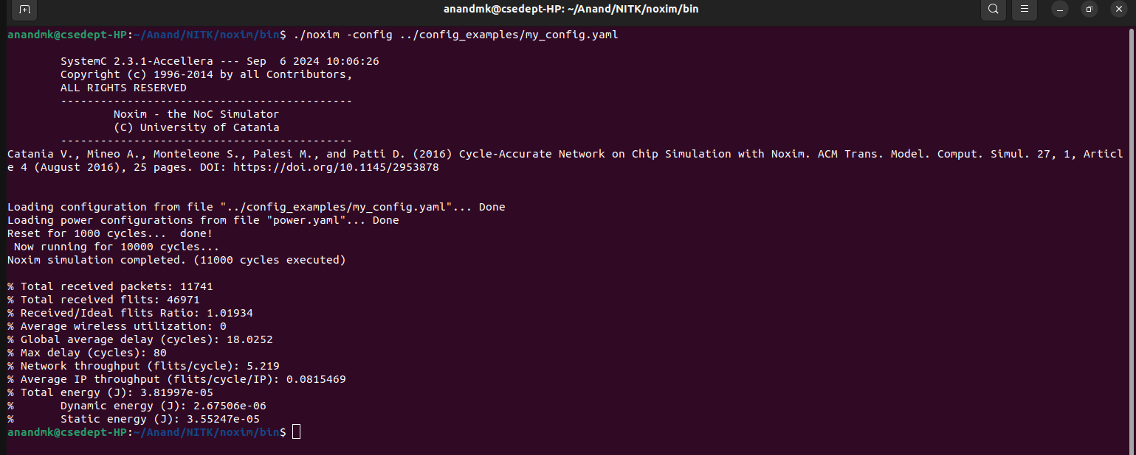
Output :
Total received packets: 11308
% Total received flits: 45239
% Received/Ideal flits Ratio: 0.981749
% Average wireless utilization: 0
% Global average delay (cycles): 18.2963
% Max delay (cycles): 94
% Network throughput (flits/cycle): 5.02656
% Average IP throughput (flits/cycle/IP): 0.0785399
% Total energy (J): 3.8123e-05
% Dynamic energy (J): 2.59829e-06
% Static energy (J): 3.55247e-05

8 * 8 MESH (Wireless)

Configuration File :

# Simple default config of a 4x4 mesh
# Each parameter is overwritten when corresponding command line value is set
#
# NOC & WIRED CONFIGURATION
#
# Topologies:
# MESH
# BUTTERFLY
# BASELINE
# OMEGA
#
# BUTTERFLY, BASELINE, and OMEGA are Delta Network topologies
#
topology: MESH
# X and Y mesh sizes
mesh_dim_x: 8
mesh_dim_y: 8
# number of flits for each router buffer
buffer_depth: 32
# size of flits, in bits
flit_size: 32
# lenght in mm of router to hub connection
r2h_link_length: 2.0
# lenght in mm of router to router connection
r2r_link_length: 1.0
n_virtual_channels: 1

# Routing algorithms:
# XY
# WEST_FIRST
# DELTA
# NORTH_LAST
# NEGATIVE_FIRST
# ODD_EVEN
# DYAD
# TABLE_BASED
# Each of the above labels should match a corresponding
# implementation in the routingAlgorithms source code directory
routing_algorithm: ODD_EVEN
routing_table_filename: ""

# Routing specific parameters
# dyad_threshold: double
dyad_threshold: 0.6

# Selection Strategies:
# RANDOM
# BUFFER_LEVEL
# NOP
# Each of the above labels should match a corresponding
# implementation in the selectionStrategies source code directory
selection_strategy: RANDOM

#
# WIRELESS CONFIGURATION
#
Hubs:
defaults:
# channels from which Hub can receive/transmit
rx_radio_channels: [0]
tx_radio_channels: [0]
# list of node tiles attached to the hub
attached_nodes: []
# size of buffers connecting the hub to tiles
to_tile_buffer_size: 4
from_tile_buffer_size: 4
# size of antenna tx/rx
rx_buffer_size: 4
tx_buffer_size: 4

# for each hub, the same parameters specified above can be customized
# If not specified, the above default values will be used
# What is usually needed to be customized specifically for each hub is
# the set of nodes that are connected to it. In this simple topology
# we have 4 hubs (0-3) connected to the four nodes of the 2x2
# sub-meshes

0:
attached_nodes: [0,1,4,5]

1:
attached_nodes: [2,3,6,7]

2:
attached_nodes: [8,9,12,13]

3:
attached_nodes: [10,11,14,15]

# Transmission channels configuration
# each channel modelizes the transmission over a given frequency that
# can be used by a set of communicating hubs
RadioChannels:
defaults:
# data rate in Gb/s affect the number of cycles required for a
# flit transmission
data_rate: 16
# bit error rate (CURRENTLY UNSUPPORTED)
ber: [0, 0]
# mac policies:

# who has the token releas only when a complete packet has
# been sent
#[TOKEN_PACKET]

# who has the token, release only after a fixed number of
# cycles, even no transmission is occurring
#[TOKEN_HOLD, num_hold_cycles]

# who has the token, holds the packet until needed for
# transmissions, until a max number of cycles is reached
#[TOKEN_MAX_HOLD, max_hold_cycles]
mac_policy: [TOKEN_PACKET]

# SIMULATION PARAMETERS
#
clock_period_ps: 1000
# duration of reset signal assertion, expressed in cycles
reset_time: 1000
# overal simulation lenght, expressed in cycles
simulation_time: 10000
# collect stats after a given number of cycles
stats_warm_up_time: 1000
# power breakdown, nodes communication details
detailed: false
# stop after a given amount of load has been processed
max_volume_to_be_drained: 0
show_buffer_stats: false

# Winoc
# enable wireless, when false, all wireless channel configuration is
# ignored
use_winoc: true
# experimental power saving strategy
use_wirxsleep: false

# Verbosity level:
# VERBOSE_OFF
# VERBOSE_LOW
# VERBOSE_MEDIUM
# VERBOSE_HIGH
verbose_mode: VERBOSE_OFF

# Trace
trace_mode: false
trace_filename: ""

min_packet_size: 4
max_packet_size: 4
packet_injection_rate: 0.01
probability_of_retransmission: 0.01

# Traffic distribution:
# TRAFFIC_RANDOM
# TRAFFIC_TRANSPOSE1
# TRAFFIC_TRANSPOSE2
# TRAFFIC_HOTSPOT
# TRAFFIC_TABLE_BASED
# TRAFFIC_BIT_REVERSAL
# TRAFFIC_SHUFFLE
# TRAFFIC_BUTTERFLY
traffic_distribution: TRAFFIC_RANDOM
# when traffic table based is specified, use the following
# configuration file
traffic_table_filename: "t.txt"

Output :

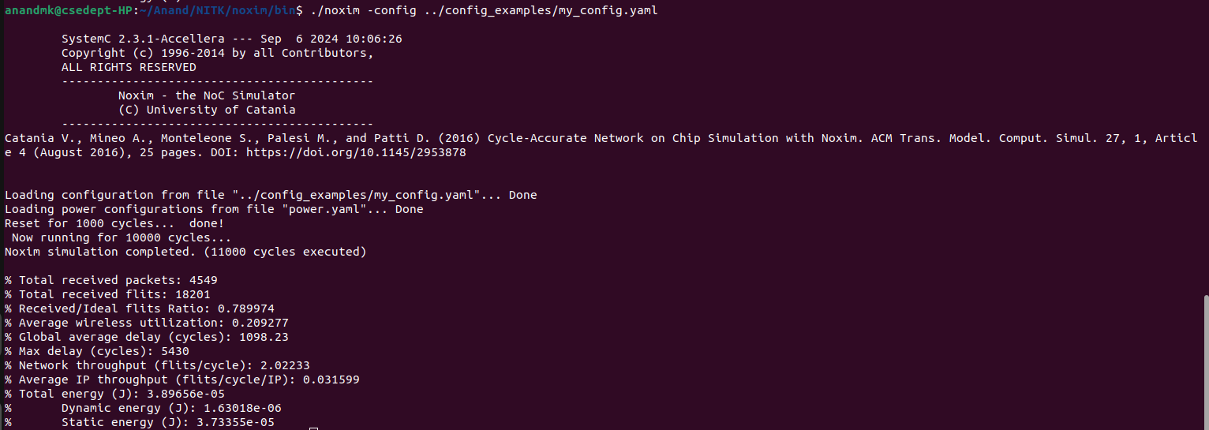
% Total received packets: 4549
% Total received flits: 18201
% Received/Ideal flits Ratio: 0.789974
% Average wireless utilization: 0.209277
% Global average delay (cycles): 1098.23
% Max delay (cycles): 5430
% Network throughput (flits/cycle): 2.02233
% Average IP throughput (flits/cycle/IP): 0.031599
% Total energy (J): 3.89656e-05
% Dynamic energy (J): 1.63018e-06
% Static energy (J): 3.73355e-05

16 * 16 MESH(Wireless)

Configuration File :

# Simple default config of a 4x4 mesh
# Each parameter is overwritten when corresponding command line value is set
#
# NOC & WIRED CONFIGURATION
#
# Topologies:
# MESH
# BUTTERFLY
# BASELINE
# OMEGA
#
# BUTTERFLY, BASELINE, and OMEGA are Delta Network topologies
#
topology: MESH
# X and Y mesh sizes
mesh_dim_x: 16
mesh_dim_y: 16
# number of flits for each router buffer
buffer_depth: 32
# size of flits, in bits
flit_size: 64
# lenght in mm of router to hub connection
r2h_link_length: 2.0
# lenght in mm of router to router connection
r2r_link_length: 1.0
n_virtual_channels: 1

# Routing algorithms:
# XY
# WEST_FIRST
# DELTA
# NORTH_LAST
# NEGATIVE_FIRST
# ODD_EVEN
# DYAD
# TABLE_BASED
# Each of the above labels should match a corresponding
# implementation in the routingAlgorithms source code directory
routing_algorithm: XY
routing_table_filename: ""

# Routing specific parameters
# dyad_threshold: double
dyad_threshold: 0.6

# Selection Strategies:
# RANDOM
# BUFFER_LEVEL
# NOP
# Each of the above labels should match a corresponding
# implementation in the selectionStrategies source code directory
selection_strategy: RANDOM

#
# WIRELESS CONFIGURATION
#
Hubs:
defaults:
# channels from which Hub can receive/transmit
rx_radio_channels: [0]
tx_radio_channels: [0]
# list of node tiles attached to the hub
attached_nodes: [0]
# size of buffers connecting the hub to tiles
to_tile_buffer_size: 4
from_tile_buffer_size: 4
# size of antenna tx/rx
rx_buffer_size: 4
tx_buffer_size: 4

# for each hub, the same parameters specified above can be customized
# If not specified, the above default values will be used
# What is usually needed to be customized specifically for each hub is
# the set of nodes that are connected to it. In this simple topology
# we have 4 hubs (0-3) connected to the four nodes of the 2x2
# sub-meshes

0:
attached_nodes: [0,1,4,5]

1:
attached_nodes: [2,3,6,7]

2:
attached_nodes: [8,9,12,13]

3:
attached_nodes: [10,11,14,15]

# Transmission channels configuration
# each channel modelizes the transmission over a given frequency that
# can be used by a set of communicating hubs
RadioChannels:
defaults:
# data rate in Gb/s affect the number of cycles required for a
# flit transmission
data_rate: 16
# bit error rate (CURRENTLY UNSUPPORTED)
ber: [0, 0]
# mac policies:

# who has the token releas only when a complete packet has
# been sent
#[TOKEN_PACKET]

# who has the token, release only after a fixed number of
# cycles, even no transmission is occurring
#[TOKEN_HOLD, num_hold_cycles]

# who has the token, holds the packet until needed for
# transmissions, until a max number of cycles is reached
#[TOKEN_MAX_HOLD, max_hold_cycles]
mac_policy: [TOKEN_PACKET]

# SIMULATION PARAMETERS
#
clock_period_ps: 1000
# duration of reset signal assertion, expressed in cycles
reset_time: 1000
# overal simulation lenght, expressed in cycles
simulation_time: 10000
# collect stats after a given number of cycles
stats_warm_up_time: 1000
# power breakdown, nodes communication details
detailed: false
# stop after a given amount of load has been processed
max_volume_to_be_drained: 0
show_buffer_stats: false

# Winoc
# enable wireless, when false, all wireless channel configuration is
# ignored
use_winoc: true
# experimental power saving strategy
use_wirxsleep: false

# Verbosity level:
# VERBOSE_OFF
# VERBOSE_LOW
# VERBOSE_MEDIUM
# VERBOSE_HIGH
verbose_mode: VERBOSE_OFF

# Trace
trace_mode: false
trace_filename: ""

min_packet_size: 4
max_packet_size: 4
packet_injection_rate: 0.005
probability_of_retransmission: 0.01

# Traffic distribution:
# TRAFFIC_RANDOM
# TRAFFIC_TRANSPOSE1
# TRAFFIC_TRANSPOSE2
# TRAFFIC_HOTSPOT
# TRAFFIC_TABLE_BASED
# TRAFFIC_BIT_REVERSAL
# TRAFFIC_SHUFFLE
# TRAFFIC_BUTTERFLY
traffic_distribution: TRAFFIC_RANDOM
# when traffic table based is specified, use the following
# configuration file
traffic_table_filename: "t.txt"

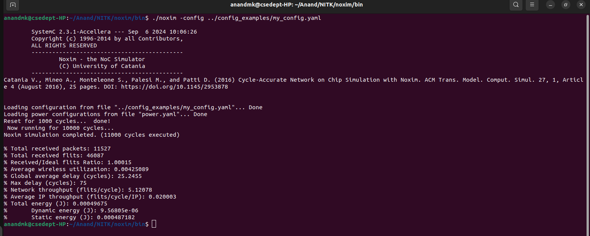
Output :
% Total received packets: 11527
% Total received flits: 46087
% Received/Ideal flits Ratio: 1.00015
% Average wireless utilization: 0.00425089
% Global average delay (cycles): 25.2455
% Max delay (cycles): 75
% Network throughput (flits/cycle): 5.12078
% Average IP throughput (flits/cycle/IP): 0.020003
% Total energy (J): 0.00049675
% Dynamic energy (J): 9.56805e-06
% Static energy (J): 0.000487182

16 * 16 MESH(Wired)

Configuration File:

# Simple default config of a 4x4 mesh
# Each parameter is overwritten when corresponding command line value is set
#
# NOC & WIRED CONFIGURATION
#
# Topologies:
# MESH
# BUTTERFLY
# BASELINE
# OMEGA
#
# BUTTERFLY, BASELINE, and OMEGA are Delta Network topologies
#
topology: MESH
# X and Y mesh sizes
mesh_dim_x: 16
mesh_dim_y: 16
# number of flits for each router buffer
buffer_depth: 32
# size of flits, in bits
flit_size: 64
# lenght in mm of router to hub connection
r2h_link_length: 2.0
# lenght in mm of router to router connection
r2r_link_length: 1.0
n_virtual_channels: 1

# Routing algorithms:
# XY
# WEST_FIRST
# DELTA
# NORTH_LAST
# NEGATIVE_FIRST
# ODD_EVEN
# DYAD
# TABLE_BASED
# Each of the above labels should match a corresponding
# implementation in the routingAlgorithms source code directory
routing_algorithm: XY
routing_table_filename: ""

# Routing specific parameters
# dyad_threshold: double
dyad_threshold: 0.6

# Selection Strategies:
# RANDOM
# BUFFER_LEVEL
# NOP
# Each of the above labels should match a corresponding
# implementation in the selectionStrategies source code directory
selection_strategy: RANDOM

#
# WIRELESS CONFIGURATION
#
Hubs:
defaults:
# channels from which Hub can receive/transmit
rx_radio_channels: [0]
tx_radio_channels: [0]
# list of node tiles attached to the hub
attached_nodes: [0]
# size of buffers connecting the hub to tiles
to_tile_buffer_size: 4
from_tile_buffer_size: 4
# size of antenna tx/rx
rx_buffer_size: 4
tx_buffer_size: 4

# for each hub, the same parameters specified above can be customized
# If not specified, the above default values will be used
# What is usually needed to be customized specifically for each hub is
# the set of nodes that are connected to it. In this simple topology
# we have 4 hubs (0-3) connected to the four nodes of the 2x2
# sub-meshes

0:
attached_nodes: [0,1,4,5]

1:
attached_nodes: [2,3,6,7]

2:
attached_nodes: [8,9,12,13]

3:
attached_nodes: [10,11,14,15]

# Transmission channels configuration
# each channel modelizes the transmission over a given frequency that
# can be used by a set of communicating hubs
RadioChannels:
defaults:
# data rate in Gb/s affect the number of cycles required for a
# flit transmission
data_rate: 16
# bit error rate (CURRENTLY UNSUPPORTED)
ber: [0, 0]
# mac policies:

# who has the token releas only when a complete packet has
# been sent
#[TOKEN_PACKET]

# who has the token, release only after a fixed number of
# cycles, even no transmission is occurring
#[TOKEN_HOLD, num_hold_cycles]

# who has the token, holds the packet until needed for
# transmissions, until a max number of cycles is reached
#[TOKEN_MAX_HOLD, max_hold_cycles]
mac_policy: [TOKEN_PACKET]

# SIMULATION PARAMETERS
#
clock_period_ps: 1000
# duration of reset signal assertion, expressed in cycles
reset_time: 1000
# overal simulation lenght, expressed in cycles
simulation_time: 10000
# collect stats after a given number of cycles
stats_warm_up_time: 1000
# power breakdown, nodes communication details
detailed: false
# stop after a given amount of load has been processed
max_volume_to_be_drained: 0
show_buffer_stats: false

# Winoc
# enable wireless, when false, all wireless channel configuration is
# ignored
use_winoc: false
# experimental power saving strategy
use_wirxsleep: false

# Verbosity level:
# VERBOSE_OFF
# VERBOSE_LOW
# VERBOSE_MEDIUM
# VERBOSE_HIGH
verbose_mode: VERBOSE_OFF

# Trace
trace_mode: false
trace_filename: ""

min_packet_size: 4
max_packet_size: 4
packet_injection_rate: 0.005
probability_of_retransmission: 0.01

# Traffic distribution:
# TRAFFIC_RANDOM
# TRAFFIC_TRANSPOSE1
# TRAFFIC_TRANSPOSE2
# TRAFFIC_HOTSPOT
# TRAFFIC_TABLE_BASED
# TRAFFIC_BIT_REVERSAL
# TRAFFIC_SHUFFLE
# TRAFFIC_BUTTERFLY
traffic_distribution: TRAFFIC_RANDOM
# when traffic table based is specified, use the following
# configuration file
traffic_table_filename: "t.txt"

Output :
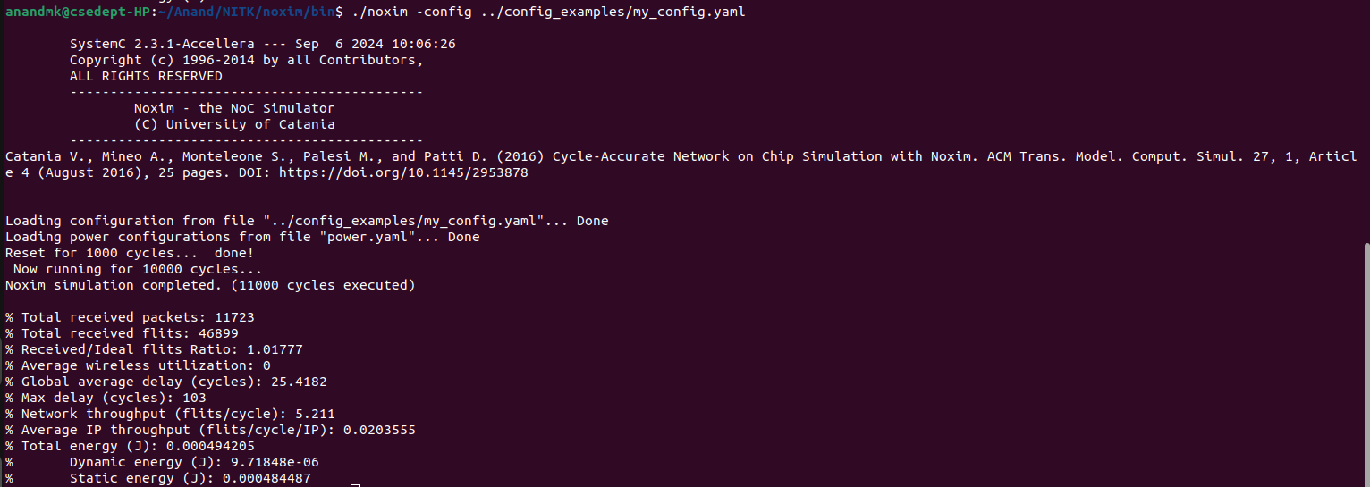

% Total received packets: 11723
% Total received flits: 46899
% Received/Ideal flits Ratio: 1.01777
% Average wireless utilization: 0
% Global average delay (cycles): 25.4182
% Max delay (cycles): 103
% Network throughput (flits/cycle): 5.211
% Average IP throughput (flits/cycle/IP): 0.0203555
% Total energy (J): 0.000494205
% Dynamic energy (J): 9.71848e-06
% Static energy (J): 0.000484487

32 * 32 MESH(Wired)

Configuration File:

# Simple default config of a 4x4 mesh
# Each parameter is overwritten when corresponding command line value is set
#
# NOC & WIRED CONFIGURATION
#
# Topologies:
# MESH
# BUTTERFLY
# BASELINE
# OMEGA
#
# BUTTERFLY, BASELINE, and OMEGA are Delta Network topologies
#
topology: MESH
# X and Y mesh sizes
mesh_dim_x: 32
mesh_dim_y: 32
# number of flits for each router buffer
buffer_depth: 32
# size of flits, in bits
flit_size: 64
# lenght in mm of router to hub connection
r2h_link_length: 2.0
# lenght in mm of router to router connection
r2r_link_length: 1.0
n_virtual_channels: 1

# Routing algorithms:
# XY
# WEST_FIRST
# DELTA
# NORTH_LAST
# NEGATIVE_FIRST
# ODD_EVEN
# DYAD
# TABLE_BASED
# Each of the above labels should match a corresponding
# implementation in the routingAlgorithms source code directory
routing_algorithm: XY
routing_table_filename: ""

# Routing specific parameters
# dyad_threshold: double
dyad_threshold: 0.6

# Selection Strategies:
# RANDOM
# BUFFER_LEVEL
# NOP
# Each of the above labels should match a corresponding
# implementation in the selectionStrategies source code directory
selection_strategy: RANDOM

#
# WIRELESS CONFIGURATION
#
Hubs:
defaults:
# channels from which Hub can receive/transmit
rx_radio_channels: [0]
tx_radio_channels: [0]
# list of node tiles attached to the hub
attached_nodes: [0]
# size of buffers connecting the hub to tiles
to_tile_buffer_size: 4
from_tile_buffer_size: 4
# size of antenna tx/rx
rx_buffer_size: 4
tx_buffer_size: 4

# for each hub, the same parameters specified above can be customized
# If not specified, the above default values will be used
# What is usually needed to be customized specifically for each hub is
# the set of nodes that are connected to it. In this simple topology
# we have 4 hubs (0-3) connected to the four nodes of the 2x2
# sub-meshes

0:
attached_nodes: [0,1,4,5]

1:
attached_nodes: [2,3,6,7]

2:
attached_nodes: [8,9,12,13]

3:
attached_nodes: [10,11,14,15]

# Transmission channels configuration
# each channel modelizes the transmission over a given frequency that
# can be used by a set of communicating hubs
RadioChannels:
defaults:
# data rate in Gb/s affect the number of cycles required for a
# flit transmission
data_rate: 32
# bit error rate (CURRENTLY UNSUPPORTED)
ber: [0, 0]
# mac policies:

# who has the token releas only when a complete packet has
# been sent
#[TOKEN_PACKET]

# who has the token, release only after a fixed number of
# cycles, even no transmission is occurring
#[TOKEN_HOLD, num_hold_cycles]

# who has the token, holds the packet until needed for
# transmissions, until a max number of cycles is reached
#[TOKEN_MAX_HOLD, max_hold_cycles]
mac_policy: [TOKEN_PACKET]

# SIMULATION PARAMETERS
#
clock_period_ps: 1000
# duration of reset signal assertion, expressed in cycles
reset_time: 1000
# overal simulation lenght, expressed in cycles
simulation_time: 10000
# collect stats after a given number of cycles
stats_warm_up_time: 1000
# power breakdown, nodes communication details
detailed: false
# stop after a given amount of load has been processed
max_volume_to_be_drained: 0
show_buffer_stats: false

# Winoc
# enable wireless, when false, all wireless channel configuration is
# ignored
use_winoc: false
# experimental power saving strategy
use_wirxsleep: false

# Verbosity level:
# VERBOSE_OFF
# VERBOSE_LOW
# VERBOSE_MEDIUM
# VERBOSE_HIGH
verbose_mode: VERBOSE_OFF

# Trace
trace_mode: false
trace_filename: ""

min_packet_size: 4
max_packet_size: 4
packet_injection_rate: 0.005
probability_of_retransmission: 0.01

# Traffic distribution:
# TRAFFIC_RANDOM
# TRAFFIC_TRANSPOSE1
# TRAFFIC_TRANSPOSE2
# TRAFFIC_HOTSPOT
# TRAFFIC_TABLE_BASED
# TRAFFIC_BIT_REVERSAL
# TRAFFIC_SHUFFLE
# TRAFFIC_BUTTERFLY
traffic_distribution: TRAFFIC_RANDOM
# when traffic table based is specified, use the following
# configuration file
traffic_table_filename: "t.txt"

Output :
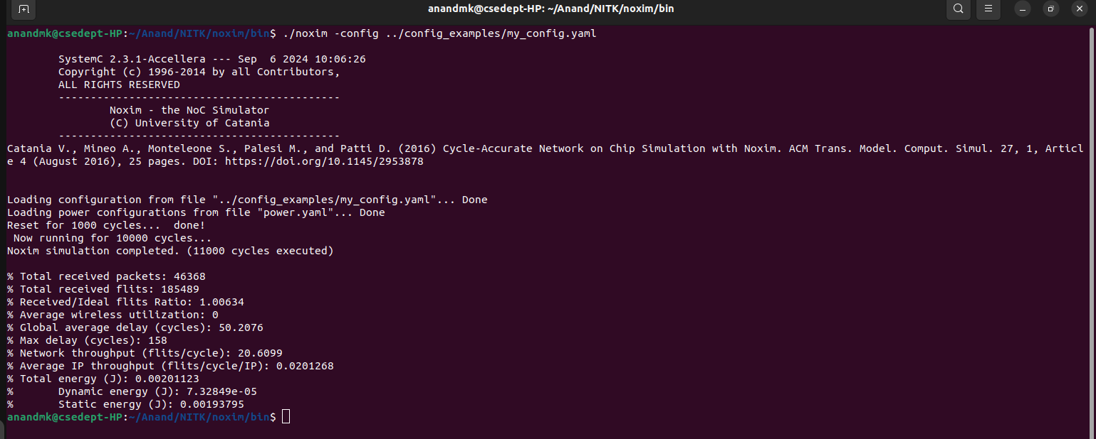
% Total received packets: 46368
% Total received flits: 185489
% Received/Ideal flits Ratio: 1.00634
% Average wireless utilization: 0
% Global average delay (cycles): 50.2076
% Max delay (cycles): 158
% Network throughput (flits/cycle): 20.6099
% Average IP throughput (flits/cycle/IP): 0.0201268
% Total energy (J): 0.00201123
% Dynamic energy (J): 7.32849e-05
% Static energy (J): 0.00193795

32 * 32 MESH(Wireless)

Configuration File:

# Simple default config of a 4x4 mesh
# Each parameter is overwritten when corresponding command line value is set
#
# NOC & WIRED CONFIGURATION
#
# Topologies:
# MESH
# BUTTERFLY
# BASELINE
# OMEGA
#
# BUTTERFLY, BASELINE, and OMEGA are Delta Network topologies
#
topology: MESH
# X and Y mesh sizes
mesh_dim_x: 32
mesh_dim_y: 32
# number of flits for each router buffer
buffer_depth: 32
# size of flits, in bits
flit_size: 64
# lenght in mm of router to hub connection
r2h_link_length: 2.0
# lenght in mm of router to router connection
r2r_link_length: 1.0
n_virtual_channels: 1

# Routing algorithms:
# XY
# WEST_FIRST
# DELTA
# NORTH_LAST
# NEGATIVE_FIRST
# ODD_EVEN
# DYAD
# TABLE_BASED
# Each of the above labels should match a corresponding
# implementation in the routingAlgorithms source code directory
routing_algorithm: XY
routing_table_filename: ""

# Routing specific parameters
# dyad_threshold: double
dyad_threshold: 0.6

# Selection Strategies:
# RANDOM
# BUFFER_LEVEL
# NOP
# Each of the above labels should match a corresponding
# implementation in the selectionStrategies source code directory
selection_strategy: RANDOM

#
# WIRELESS CONFIGURATION
#
Hubs:
defaults:
# channels from which Hub can receive/transmit
rx_radio_channels: [0]
tx_radio_channels: [0]
# list of node tiles attached to the hub
attached_nodes: [0]
# size of buffers connecting the hub to tiles
to_tile_buffer_size: 4
from_tile_buffer_size: 4
# size of antenna tx/rx
rx_buffer_size: 4
tx_buffer_size: 4

# for each hub, the same parameters specified above can be customized
# If not specified, the above default values will be used
# What is usually needed to be customized specifically for each hub is
# the set of nodes that are connected to it. In this simple topology
# we have 4 hubs (0-3) connected to the four nodes of the 2x2
# sub-meshes

0:
attached_nodes: [0,1,4,5]

1:
attached_nodes: [2,3,6,7]

2:
attached_nodes: [8,9,12,13]

3:
attached_nodes: [10,11,14,15]

# Transmission channels configuration
# each channel modelizes the transmission over a given frequency that
# can be used by a set of communicating hubs
RadioChannels:
defaults:
# data rate in Gb/s affect the number of cycles required for a
# flit transmission
data_rate: 32
# bit error rate (CURRENTLY UNSUPPORTED)
ber: [0, 0]
# mac policies:

# who has the token releas only when a complete packet has
# been sent
#[TOKEN_PACKET]

# who has the token, release only after a fixed number of
# cycles, even no transmission is occurring
#[TOKEN_HOLD, num_hold_cycles]

# who has the token, holds the packet until needed for
# transmissions, until a max number of cycles is reached
#[TOKEN_MAX_HOLD, max_hold_cycles]
mac_policy: [TOKEN_PACKET]

# SIMULATION PARAMETERS
#
clock_period_ps: 1000
# duration of reset signal assertion, expressed in cycles
reset_time: 1000
# overal simulation lenght, expressed in cycles
simulation_time: 10000
# collect stats after a given number of cycles
stats_warm_up_time: 1000
# power breakdown, nodes communication details
detailed: false
# stop after a given amount of load has been processed
max_volume_to_be_drained: 0
show_buffer_stats: false

# Winoc
# enable wireless, when false, all wireless channel configuration is
# ignored
use_winoc: true
# experimental power saving strategy
use_wirxsleep: false

# Verbosity level:
# VERBOSE_OFF
# VERBOSE_LOW
# VERBOSE_MEDIUM
# VERBOSE_HIGH
verbose_mode: VERBOSE_OFF

# Trace
trace_mode: false
trace_filename: ""

min_packet_size: 4
max_packet_size: 4
packet_injection_rate: 0.005
probability_of_retransmission: 0.01

# Traffic distribution:
# TRAFFIC_RANDOM
# TRAFFIC_TRANSPOSE1
# TRAFFIC_TRANSPOSE2
# TRAFFIC_HOTSPOT
# TRAFFIC_TABLE_BASED
# TRAFFIC_BIT_REVERSAL
# TRAFFIC_SHUFFLE
# TRAFFIC_BUTTERFLY
traffic_distribution: TRAFFIC_RANDOM
# when traffic table based is specified, use the following
# configuration file
traffic_table_filename: "t.txt"

Output:

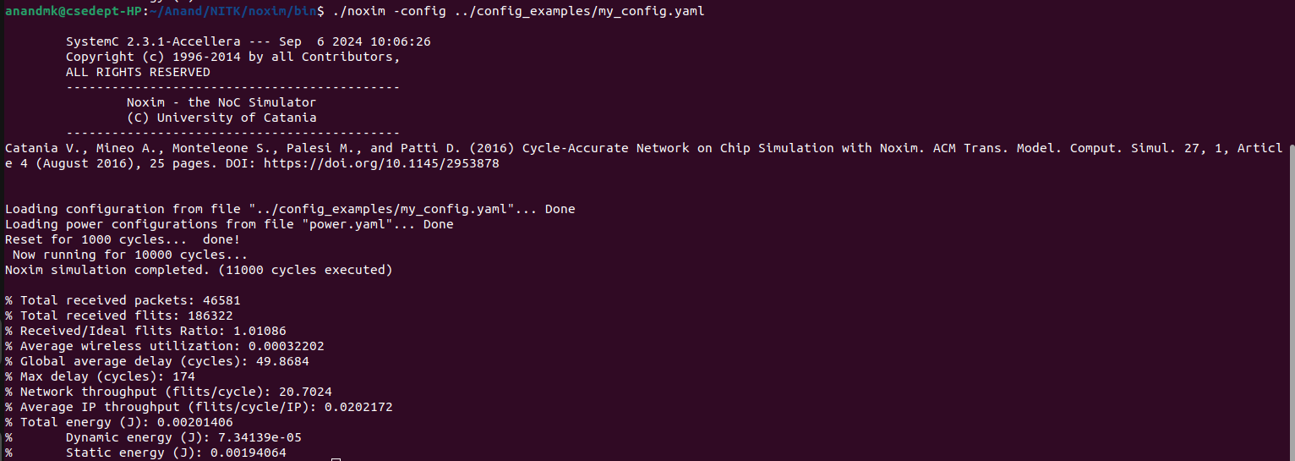

50 * 50 MESH(Wired)

Configuration File

# Simple default config of a 4x4 mesh
# Each parameter is overwritten when corresponding command line value is set
#
# NOC & WIRED CONFIGURATION
#
# Topologies:
# MESH
# BUTTERFLY
# BASELINE
# OMEGA
#
# BUTTERFLY, BASELINE, and OMEGA are Delta Network topologies
#
topology: MESH
# X and Y mesh sizes
mesh_dim_x: 50
mesh_dim_y: 50
# number of flits for each router buffer
buffer_depth: 8
# size of flits, in bits
flit_size: 64
# lenght in mm of router to hub connection
r2h_link_length: 2.0
# lenght in mm of router to router connection
r2r_link_length: 1.0
n_virtual_channels: 1

# Routing algorithms:
# XY
# WEST_FIRST
# DELTA
# NORTH_LAST
# NEGATIVE_FIRST
# ODD_EVEN
# DYAD
# TABLE_BASED
# Each of the above labels should match a corresponding
# implementation in the routingAlgorithms source code directory
routing_algorithm: XY
routing_table_filename: ""

# Routing specific parameters
# dyad_threshold: double
dyad_threshold: 0.6

# Selection Strategies:
# RANDOM
# BUFFER_LEVEL
# NOP
# Each of the above labels should match a corresponding
# implementation in the selectionStrategies source code directory
selection_strategy: RANDOM

#
# WIRELESS CONFIGURATION
#
Hubs:
defaults:
# channels from which Hub can receive/transmit
rx_radio_channels: [0]
tx_radio_channels: [0]
# list of node tiles attached to the hub
attached_nodes: []
# size of buffers connecting the hub to tiles
to_tile_buffer_size: 4
from_tile_buffer_size: 4
# size of antenna tx/rx
rx_buffer_size: 4
tx_buffer_size: 4

# for each hub, the same parameters specified above can be customized
# If not specified, the above default values will be used
# What is usually needed to be customized specifically for each hub is
# the set of nodes that are connected to it. In this simple topology
# we have 4 hubs (0-3) connected to the four nodes of the 2x2
# sub-meshes

0:
attached_nodes: [0,1,4,5]

1:
attached_nodes: [2,3,6,7]

2:
attached_nodes: [8,9,12,13]

3:
attached_nodes: [10,11,14,15]

# Transmission channels configuration
# each channel modelizes the transmission over a given frequency that
# can be used by a set of communicating hubs
RadioChannels:
defaults:
# data rate in Gb/s affect the number of cycles required for a
# flit transmission
data_rate: 16
# bit error rate (CURRENTLY UNSUPPORTED)
ber: [0, 0]
# mac policies:

# who has the token releas only when a complete packet has
# been sent
#[TOKEN_PACKET]

# who has the token, release only after a fixed number of
# cycles, even no transmission is occurring
#[TOKEN_HOLD, num_hold_cycles]

# who has the token, holds the packet until needed for
# transmissions, until a max number of cycles is reached
#[TOKEN_MAX_HOLD, max_hold_cycles]
mac_policy: [TOKEN_PACKET]

# SIMULATION PARAMETERS
#
clock_period_ps: 1000
# duration of reset signal assertion, expressed in cycles
reset_time: 1000
# overal simulation lenght, expressed in cycles
simulation_time: 10000
# collect stats after a given number of cycles
stats_warm_up_time: 1000
# power breakdown, nodes communication details
detailed: false
# stop after a given amount of load has been processed
max_volume_to_be_drained: 0
show_buffer_stats: false

# Winoc
# enable wireless, when false, all wireless channel configuration is
# ignored
use_winoc: false
# experimental power saving strategy
use_wirxsleep: false

# Verbosity level:
# VERBOSE_OFF
# VERBOSE_LOW
# VERBOSE_MEDIUM
# VERBOSE_HIGH
verbose_mode: VERBOSE_OFF

# Trace
trace_mode: false
trace_filename: ""

min_packet_size: 4
max_packet_size: 4
packet_injection_rate: 0.005
probability_of_retransmission: 0.01

# Traffic distribution:
# TRAFFIC_RANDOM
# TRAFFIC_TRANSPOSE1
# TRAFFIC_TRANSPOSE2
# TRAFFIC_HOTSPOT
# TRAFFIC_TABLE_BASED
# TRAFFIC_BIT_REVERSAL
# TRAFFIC_SHUFFLE
# TRAFFIC_BUTTERFLY
traffic_distribution: TRAFFIC_RANDOM
# when traffic table based is specified, use the following
# configuration file
traffic_table_filename: "t.txt"

Output:

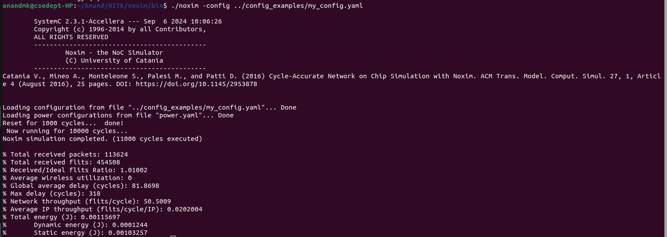

50 * 50 MESH(Wireless)

Configuration File

# Simple default config of a 4x4 mesh
# Each parameter is overwritten when corresponding command line value is set
#
# NOC & WIRED CONFIGURATION
#
# Topologies:
# MESH
# BUTTERFLY
# BASELINE
# OMEGA
#
# BUTTERFLY, BASELINE, and OMEGA are Delta Network topologies
#
topology: MESH
# X and Y mesh sizes
mesh_dim_x: 50
mesh_dim_y: 50
# number of flits for each router buffer
buffer_depth: 8
# size of flits, in bits
flit_size: 64
# lenght in mm of router to hub connection
r2h_link_length: 2.0
# lenght in mm of router to router connection
r2r_link_length: 1.0
n_virtual_channels: 1

# Routing algorithms:
# XY
# WEST_FIRST
# DELTA
# NORTH_LAST
# NEGATIVE_FIRST
# ODD_EVEN
# DYAD
# TABLE_BASED
# Each of the above labels should match a corresponding
# implementation in the routingAlgorithms source code directory
routing_algorithm: XY
routing_table_filename: ""

# Routing specific parameters
# dyad_threshold: double
dyad_threshold: 0.6

# Selection Strategies:
# RANDOM
# BUFFER_LEVEL
# NOP
# Each of the above labels should match a corresponding
# implementation in the selectionStrategies source code directory
selection_strategy: RANDOM

#
# WIRELESS CONFIGURATION
#
Hubs:
defaults:
# channels from which Hub can receive/transmit
rx_radio_channels: [0]
tx_radio_channels: [0]
# list of node tiles attached to the hub
attached_nodes: []
# size of buffers connecting the hub to tiles
to_tile_buffer_size: 4
from_tile_buffer_size: 4
# size of antenna tx/rx
rx_buffer_size: 4
tx_buffer_size: 4

# for each hub, the same parameters specified above can be customized
# If not specified, the above default values will be used
# What is usually needed to be customized specifically for each hub is
# the set of nodes that are connected to it. In this simple topology
# we have 4 hubs (0-3) connected to the four nodes of the 2x2
# sub-meshes

0:
attached_nodes: [0,1,4,5]

1:
attached_nodes: [2,3,6,7]

2:
attached_nodes: [8,9,12,13]

3:
attached_nodes: [10,11,14,15]

# Transmission channels configuration
# each channel modelizes the transmission over a given frequency that
# can be used by a set of communicating hubs
RadioChannels:
defaults:
# data rate in Gb/s affect the number of cycles required for a
# flit transmission
data_rate: 16
# bit error rate (CURRENTLY UNSUPPORTED)
ber: [0, 0]
# mac policies:

# who has the token releas only when a complete packet has
# been sent
#[TOKEN_PACKET]

# who has the token, release only after a fixed number of
# cycles, even no transmission is occurring
#[TOKEN_HOLD, num_hold_cycles]

# who has the token, holds the packet until needed for
# transmissions, until a max number of cycles is reached
#[TOKEN_MAX_HOLD, max_hold_cycles]
mac_policy: [TOKEN_PACKET]

# SIMULATION PARAMETERS
#
clock_period_ps: 1000
# duration of reset signal assertion, expressed in cycles
reset_time: 1000
# overal simulation lenght, expressed in cycles
simulation_time: 10000
# collect stats after a given number of cycles
stats_warm_up_time: 1000
# power breakdown, nodes communication details
detailed: false
# stop after a given amount of load has been processed
max_volume_to_be_drained: 0
show_buffer_stats: false

# Winoc
# enable wireless, when false, all wireless channel configuration is
# ignored
use_winoc: true
# experimental power saving strategy
use_wirxsleep: false

# Verbosity level:
# VERBOSE_OFF
# VERBOSE_LOW
# VERBOSE_MEDIUM
# VERBOSE_HIGH
verbose_mode: VERBOSE_OFF

# Trace
trace_mode: false
trace_filename: ""

min_packet_size: 4
max_packet_size: 4
packet_injection_rate: 0.005
probability_of_retransmission: 0.01

# Traffic distribution:
# TRAFFIC_RANDOM
# TRAFFIC_TRANSPOSE1
# TRAFFIC_TRANSPOSE2
# TRAFFIC_HOTSPOT
# TRAFFIC_TABLE_BASED
# TRAFFIC_BIT_REVERSAL
# TRAFFIC_SHUFFLE
# TRAFFIC_BUTTERFLY
traffic_distribution: TRAFFIC_RANDOM
# when traffic table based is specified, use the following
# configuration file
traffic_table_filename: "t.txt"

Output:

